SIMPLE HOUSEHOLD BUDGET ENVELOPE MANAGER
@CREATIVITY THINK (9483175986/7019689991)

ABSTRACT:
Simple Household Budget Envelope Manager is a web-based application designed to help families, students, and shared flats manage personal and household budgets efficiently. The platform uses “budget envelopes” to allocate spending limits for categories like groceries, rent, travel, and entertainment. Users can log expenses, track progress, visualize monthly spending through charts, and export data. Administrators can configure default envelopes, manage tips and articles, and monitor anonymized spending trends via dashboards. Developed with Django and Django REST Framework for backend processing, and React with axios and recharts for frontend interactions, the system provides a structured, transparent, and insightful budgeting solution..

INTRODUCTION OF THE PROJECT:
Managing household or personal budgets is often challenging due to scattered records, inconsistent tracking, and lack of visibility into category-wise spending. Traditional methods, such as notebooks or spreadsheets, fail to provide real-time insights and actionable summaries. The Simple Household Budget Envelope Manager addresses these limitations by offering a digital solution with intuitive visualizations, clear category limits, and automatic expense tracking. Users can plan, monitor, and adjust budgets while administrators gain insights into aggregate spending trends for guidance and optimization..

PROJECT OBJECTIVES:

• Allow users to create budget envelopes with defined monthly limits
• Enable logging of expenses per envelope with real-time tracking
• Display remaining balances and progress bars for each category
• Provide charts and graphs for monthly spending analysis
• Allow exporting of spending data in CSV format
• Provide administrators with configurable default envelope templates
• Manage educational content such as budgeting tips and articles
• Monitor anonymized spending trends across users and categories
• Offer a dashboard for adoption metrics and aggregate analytics
• Ensure secure, scalable, and responsive system design

PROBLEM OF THE STATEMENT:
Many individuals and households struggle with budgeting due to lack of structured systems to categorize and monitor spending. Manual tracking is error-prone, time-consuming, and provides limited insights into spending patterns. Administrators, such as financial advisors or household managers, cannot easily aggregate or analyze trends. The Simple Household Budget Envelope Manager solves these challenges by digitizing envelope-based budgeting, providing real-time tracking, visual analytics, and administrative oversight..

MOTIVATION OF THE PROJECT:
• To simplify budgeting and spending management for individuals and households
• To reduce overspending and improve financial discipline
• To provide clear visualization of category-wise budget usage
• To allow easy tracking, logging, and export of expenses
• To deliver dashboards and aggregate analytics for administrators
• To offer a user-friendly interface for both individuals and households
• To enhance financial awareness and decision-making
• To centralize budgeting processes with secure backend support

BLOCK DAIGRAM OF PROJECT:

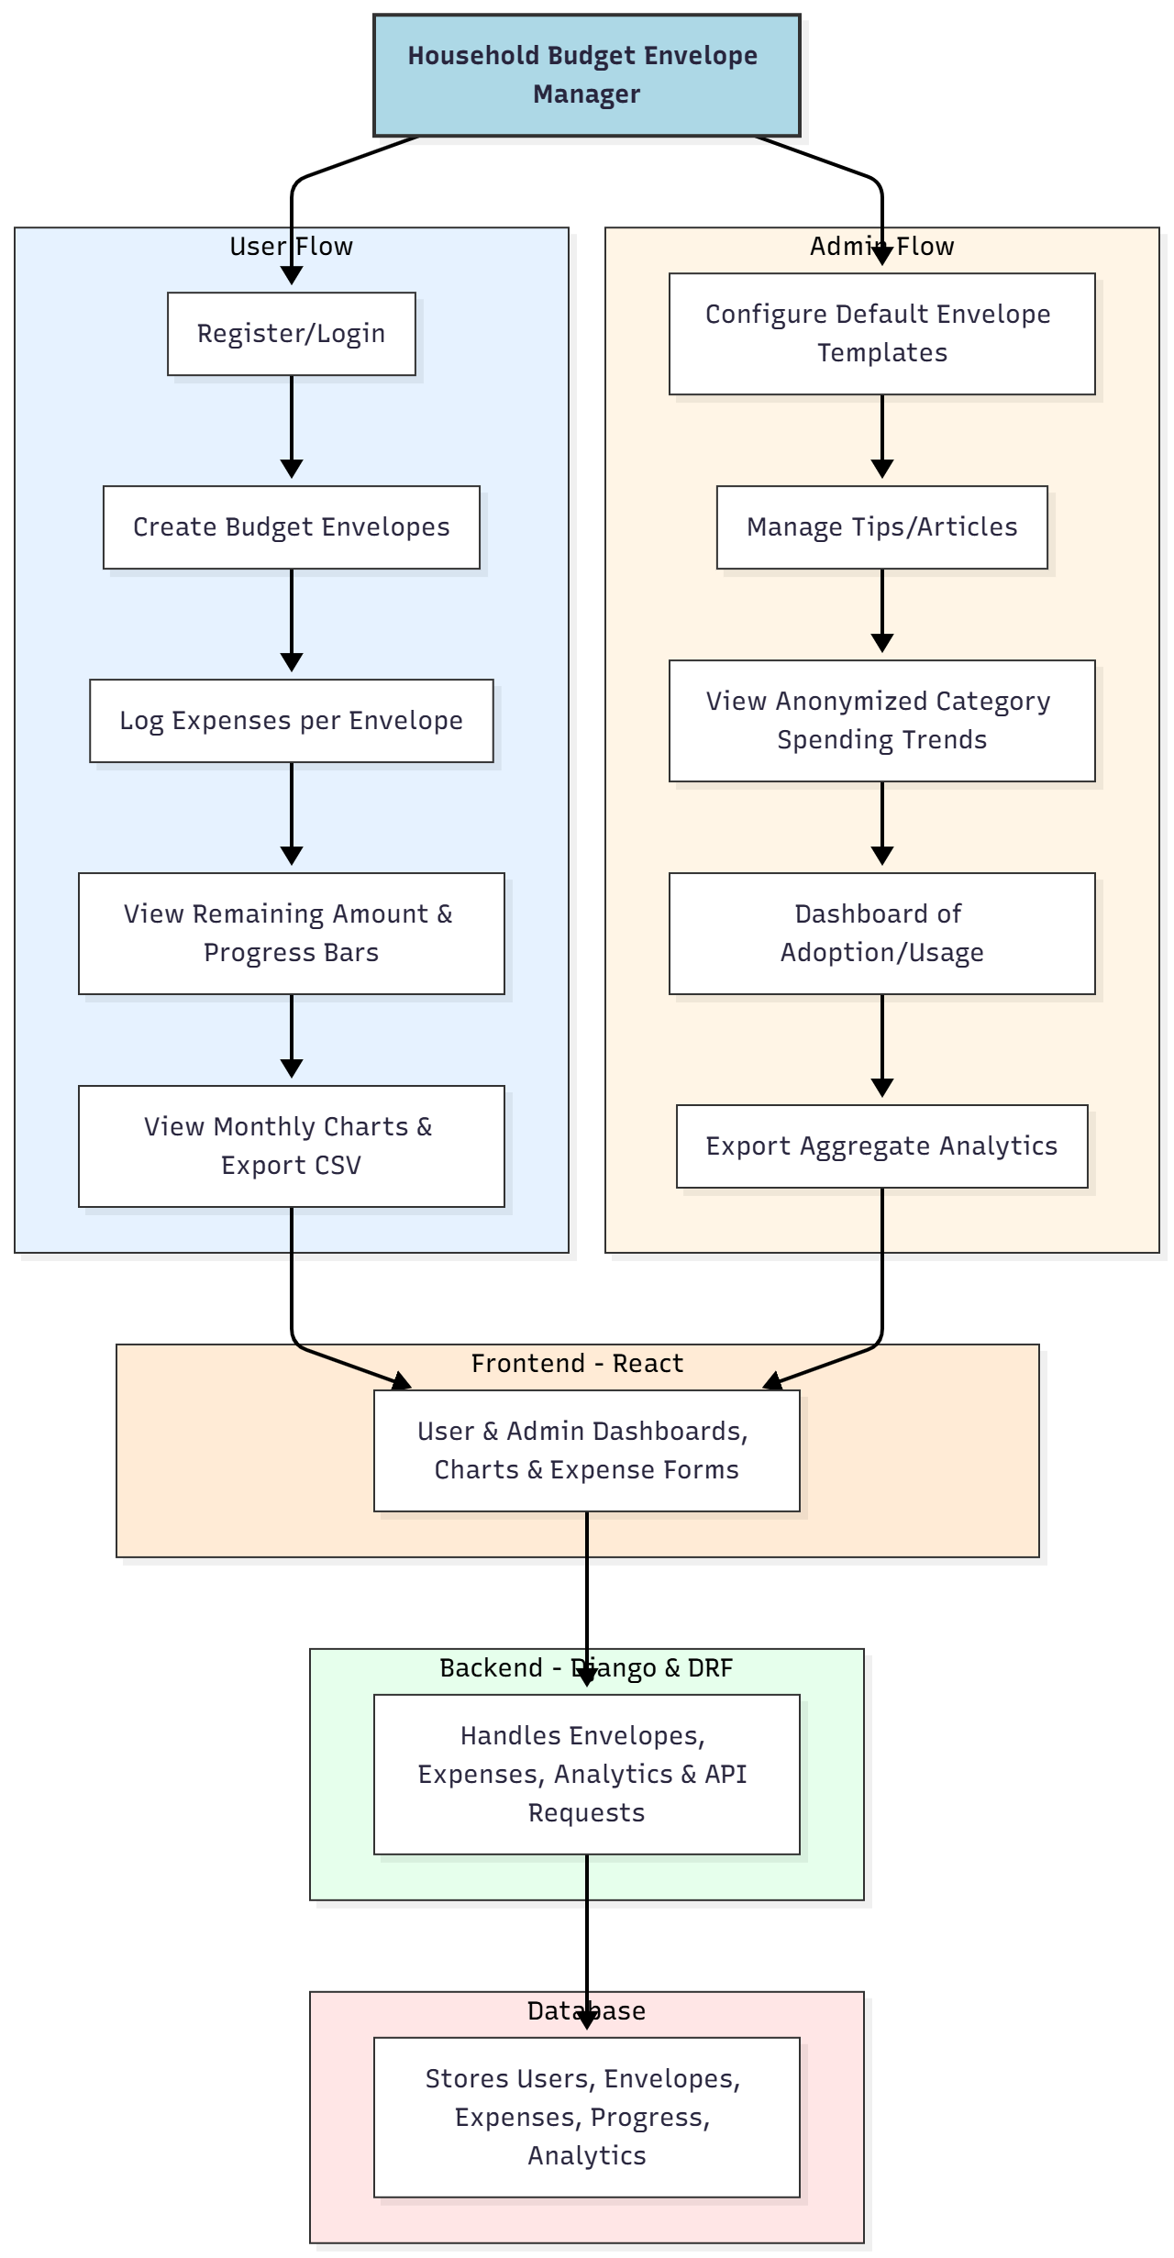

WORKING OF THE PROJECT:
Users register and create budget envelopes with monthly limits for categories such as groceries, rent, travel, and utilities. Each expense is logged under the appropriate envelope, and the system calculates remaining amounts and updates progress bars. Monthly charts visualize spending patterns, while CSV export allows detailed record-keeping. Administrators configure default envelope templates, provide tips and articles, track anonymized category spending, monitor adoption metrics, and export aggregated analytics. The backend ensures secure storage, data processing, and API interactions, while the frontend displays interactive dashboards and progress tracking, providing users with an organized, transparent, and effective budgeting experience..

SOFTWARE REQUIREMENT:
- Backend:
  - Python 3.x
  - Django
  - Django REST Framework
  - SQLite/PostgreSQL
- Frontend:
  - Node.js and npm
  - React.js
  - Axios
- Development Tools:
  - Visual Studio Code
  - Postman (for testing APIs)
  - Git/GitHub (for version control)
- Server/Deployment (Optional):
  - Gunicorn, Nginx, or Heroku/AWS for hosting

ADVANTAGES OF THE PROJECT:

• Enables structured envelope-based budgeting
• Tracks spending and progress in real time
• Visualizes spending trends through charts
• Reduces overspending and improves financial discipline
• Supports CSV export for records and reporting
• Provides administrative dashboards and analytics
• Facilitates household financial planning for families, students, and shared flats
• Scalable, secure, and easy-to-use web application

APPLICATIONS OF THE PROJECT:
• Family budgeting management
• Student or shared flat expense tracking
• Personal financial discipline and awareness
• Household finance dashboards
• Expense tracking for roommates or co-living situations

REFERENCES:

- Django REST Framework Documentation — Django Software Foundation. Django Documentation. Available: https://docs.djangoproject.com/
- Django REST Framework. DRF Documentation. Available: https://www.django-rest-framework.org/
- React. React Official Documentation. Available: https://reactjs.org/docs/getting-started.html
- Redux. Redux Documentation. Available: https://redux.js.org/introduction/getting-started
- PostgreSQL Global Development Group. PostgreSQL Documentation. Available: https://www.postgresql.org/docs/
- MySQL. MySQL Reference Manual. Available: https://dev.mysql.com/doc/
- Git. Git Documentation. Available: https://git-scm.com/doc
- Node.js. Node.js Documentation. Available: https://nodejs.org/en/docs/
- Axios. Axios Documentation. Available: https://axios-http.com/docs/intro
- Socket.io Documentation – https://socket.io/docs/

